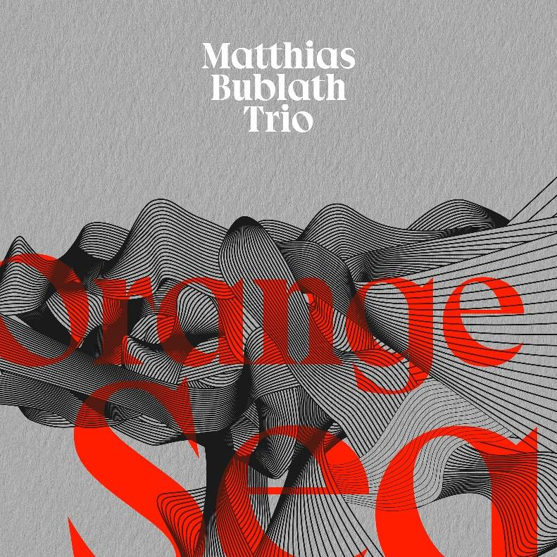

After almost a decade as a freelancer in New York, various solo and sideman projects, a Hammond trio and his celebrated and award-winning Eight Cylinder Big Band, Munich pianist Matthias Bublath is now exploring the traditional piano trio format. With influences ranging from gospel, latin, funk, and the socio-political movements of the 20th Century , ‘Orange Sea’ is set to release on the 30th of September on X records.
At the forefront of the record are bluesy, soulful, melodic compositions that serve as a playful springboard for the ensemble to explore and push each other to their limits. Syncopated rhythmic unison lines at breakneck speeds, deep-swinging groove, and emotive harmony emphasize musicality and virtuosity in equal measure.
Bublath’s improvisational freedom is facilitated and secured by his two colleagues who are just as stylistically flexible as he. Peter Cudek, the Slovakian bass player, is versatile and original, equally as able to carry melodies as he is able to showcase his understated virtuosity. Christian Lettner, newly appointed professor for percussion in Munich and long-time member of revered fusion outfit Doldinger's Passport, is a highly sought-after drummer for countless projects ranging from jazz, classical percussion, to pop and R&B.
Inspired by American cultural and social signposts of the last 100 years, the compositions are a celebration of the nation’s greatest artists, and a commentary on the dark underbelly of its society. Most Foul alludes to Bob Dylan’s ballad "Murder Most Foul" written about the Kennedy assassination, Zapruder references those who documented the assassination attempt on Super-8 in Dallas, while Sherman Bros flirts with the playful swing of Disney's late '60s soundtracks, and Monk Ponk’s walking bass, echoes of stride piano and rich chord voicings are a tribute to Thelonious Monk.
The imagery invoked by the phrase Orange Sea could be a sunset on the American west coast, or also the reflection of napalm from the burning forests on the waters of Vietnam. Superficially almost a chorale in its complexity, but in concept melodic straight-ahead jazz with a postmodern approach, stylistically each piece stands for itself, and as an album they result in an ambiguous and open sonic landscape.

Matthias Bublath | Piano Christian Lettner | Drums
Peter Cudek | Bass

Private Streaming: Soundcloud
WAVs: download here | Photos: download here
Artist website: www.matthiasbublath.com

Track Listing
01. Most Foul [6’13]
02. Sherman Bros [5’17]
03. Angry Birds [4’47]
04. One For Kenny [4’31]
05. Zapruder. [4’43]
06. Science Lab [5’25]
07. Samba Norte Sul [6’38]
08. Monk Ponk [5’30]
09. What Are You Doing For The Rest Of Your Life [6’09]
10. Vinci [4’16]

Total: 53’30

